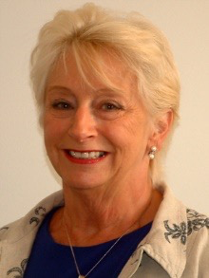
Margaret Stone Norfolk County Councillor
Vice Chairman of Norfolk Council

Parish report. County councillors:
55 Conservative:17.Labour 11 Liberal Democrat. 1 Independent. New committees established with proportional representation.

ApprenticEships Norfolk
Less able students who fail either at interview or on application, who are still able, will be offered apprenticeship in small business and have independent one to one mentoring. This supports small business who are unable to recruit in the conventional way

NorFolk economic SnaPshot
We have a higher rate of people in employment than the rest of the country of 76.7%

A47 Alliance . Highways England awArded £300 miLlion 2014/2020. New fUndinG discussion now prioritise following
Blofield to north Burlingham dualling
Priorities now will include the Acle straight Duelling.
Roundabouts at Hales and Heckingham Norfolk County council already funded and start within a couple of months gas pipe delay with loddon
Roundabout at Loddon/. Mundham :Developer funding with new housing supported by NCC and South Norfolk
Thickthorn junction improvement
- International Aviation Academy. £12 .5 million development. Collaboration with NORSE and NCC

Pledge:
Protect the frontline services :
Keep costs down. Financial stability
Work within our budgets
More opportunities for young people
Finishing the Northern Distributer route
Commercially minded and maximise opportunities to create income.
Supporting NORSE our wholly owned company to expand and bringing back profits the re invest in Norfolk ie. Refuse collection, property services, supported housing. Transport for other councils. Buses etc
Redevelop surplus office space
Early intervention and integrated services to ensure only those who need hospital care are admitted and supporting people with social needs at home as far as possible
Support independent living in supported housing

